**Software Design Specification**

**Document**

**Integrated Solution**

**Name: Ashish Kumar**

**Roll No: 13000113022**

**Department: CSE**

**Version: 1** **Date: 03/29/2017**

**Table of Contents**

1 Introduction 1

1.1 System Overview 1

1.1.1 High level Description of system 1

1.1.2 Interaction with external system 1

1.1.3 System Issues 1

1.2 Definitions, Acronyms, and Abbreviations 1

1.3 References 1

1.4 Document Map 2

2 Design Considerations 3

2.1 Assumptions 3

2.2 Constraints 3

2.3 System Environment 3

2.4 Design Methodology 3

3 Architectural (High-level) Design 4

3.1 Overview 4

3.2 Conceptual (or Logical) View 4

4 Low Level Design 5

4.1 Component 1: Class Diagram 5

5 User Interface Design 6

5.1 Application Control 6

5.2 Screen 1: Input 6

5.3 Screen 2: Output 6

# Introduction

## System Overview

### High level Description of system

The objectives of the project are:

1. To create a C or Java program for accepting an integer (n) and generate following point series:

x: n integer points from 0 to (n-1)

y: y=x*x

1. To design an effective mechanism for plotting these with minimal or nil effort from the user.

### Interaction with external system

The system after generating integer points will call a python script which in turn will plot the required graph. Hence, our java program will interact with python script to get desired output.

### System Issues

1. Environment variables are not set properly.
2. Hardware failure
3. Power Failure

## Definitions, Acronyms, and Abbreviations

* Class:- Class is the prototype for creating object.
* Object:- It is an instance of a class.
* Pylab:- A python module which contains definitions for plot related methods.
* Plot:- A function in python for plotting graph.

## References

1. Spoken- tutorial video lectures on python.
2. UD sir’s lectures on java.
3. Tutorial points notes on python.

## Document Map

Following are the major sections of this document:

* Assumptions: It describes any assumption, background, or dependencies of the software, its use, the operational environment, or significant project issues
* Constraints: Describe any constraints on the system that have a significant impact on the design of the system.
* System Environment: It describes the hardware and software that the system must operate in and interact with.
* Design methodology: It Summarize the approach that will be used to create and evolve the design for this system.
* Logical view: It provides and describes a diagram that shows the various components and how they are connected.
* Low level design: It provides the low-level design for each of the system components identified in the logical view.
* User Interface: it illustrates all major user-interface screens and describes the behavior and state changes that the user will experience.

# Design Considerations

## Assumptions

Following are some assumptions for our project:

* Python is pre-installed in the system.
* Java JDK and JRE are pre-installed on the system.
* Path for java is set properly.
* Other Environmental variables need to run the program is set properly.

## Constraints

Following are some constraints for our system:

* The System should be able to handle invalid inputs.
* The System should show the output for negative integers also.
* There should not be a case where both java and python programs need to be run. Java program should execute python script.

## System Environment

|  |  |
| --- | --- |
| **Hardware/Software** | **Specifications** |
| Operating System | Windows 8.1 |
| Hard Disk | 100 GB |
| Processor | Intel Pentium-1 |
| RAM | 1 GB |
| Software Requirements | Java 1.7, Python-3, notepad++ |

## Design Methodology

We are using Object Oriented design methodology where there is a class which includes methods for generating integer points. The same program will execute a python script. UML diagrams are drawn in Low level design section of this document.

# Architectural (High-level) Design

## Overview

The whole system consists of two programs. One is java program which will be used to generate series and other is python script which will plot the graph.

## Conceptual (or Logical) View

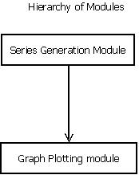

This Diagram represents the dependency between different modules used in developing the system.

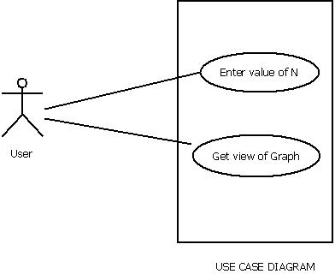

# Low Level Design

## Component 1: Class Diagram

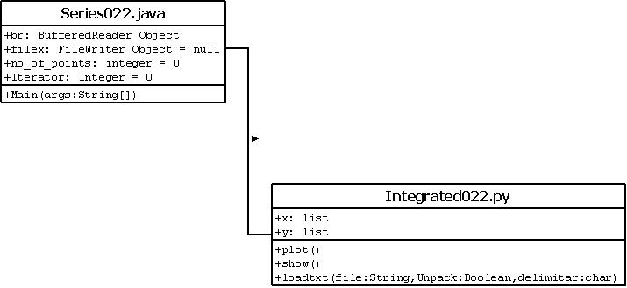

# User Interface Design

## Application Control

After running the java program, User is asked to give input. If user gives invalid input, then appropriate message will be displayed otherwise it will call python script to show the output graph.

## Screen 1: Input

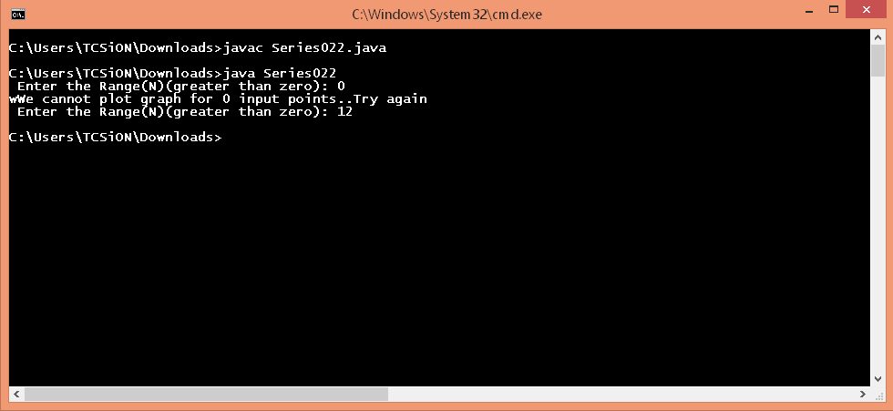

## Screen 2: Output

